1.The Battery Active Balancer (JK-B5A24S) is a balancing management system tailored for large capacity series connected battery packs. all

Hengyi uses supercapacitors as a medium to achieve active energy transfer balance.

The balancer is suitable for 4 to 24 series battery packs and has voltage acquisition and balancing functions. During the operation of the balance instrument, energy transfer is carried out with a continuous 5A balance current, which does not depend on the voltage difference of the series connected battery cells in the battery pack. The collection range of individual voltage is 1 V to 5 V, with an accuracy of ± 5 mV. Suitable for all types of electricity on the market, such as lithium iron phosphate, ternary lithium, titanium acid, lead acid, etc

Pool type.

The balancer has Bluetooth communication function and is equipped with a mobile app software. You can connect the balancer through Bluetooth on your mobile phone to view battery voltage, balance status, modify parameters, and perform other operations. The balancer is small in size and easy to carry, and can be widely used for balancing and maintaining batteries in small sightseeing vehicles, commuters, shared cars, high-power energy storage, backup power sources for base stations, solar power stations, and other areas

Repair.

2 Main technical parameters

2.1 Main technical indicators

◆ Supports 4-24 series battery packs;

◆ Real time, active, and balanced energy transfer, with a pressure difference between individual batteries ≤ 5mV after reaching equilibrium;

◆ Single cell voltage range 1V to 5V, accuracy ± 5mV;

◆ Supports all types of batteries, including ternary, lithium iron, lead-acid, supercapacitors, etc;

◆ The balanced current is independently set within the range of 0.8A to 5A, without relying on the voltage difference of individual battery cells;

◆ Supports balanced cascading, suitable for battery packs with 24 or more strings, theoretically capable of infinite cascading;

◆ Bluetooth communication function, equipped with a mobile app, supporting Android and IOS, and real-time viewing of battery cell status;

◆ Balance line resistance detection to detect wiring errors in advance;

◆ Power supply range: 12V~100V;

2.2 Environmental conditions for use

a) Working temperature range: -20 ℃~70 ℃;

b) Power requirements: 12-100V, can be powered by a battery.

c) Power consumption: balanced state 10mA@100V , non-equilibrium state 6mA@100V .

3. Connector and Interface Description

3.1 Description of connector and power button positions

The positions of the connector and power button are shown in Figure 1.

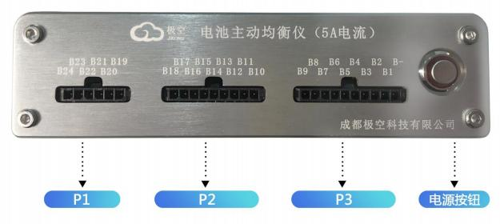

Figure 1 Connector schematic diagram

3.2 Definition and description of connectors and power buttons

The definitions of connectors and power buttons are shown in Table 1.

Definition of Device Pin Number Names

P3

1 B - Battery negative terminal

2 B1 1st string battery positive pole

3 B2 2nd string battery positive pole

4 B3 3rd string battery positive pole

5 B4 4th string battery positive pole

6 B5 5th string battery positive pole

7 B6 6th string battery positive pole

8 B7 7th string battery positive pole

9 B8 8th string battery positive pole

10 B9 9th string battery positive pole

P2

1 B10 10th string battery positive pole

2 B11 11th string battery positive pole

3 B12 12th string battery positive pole

4 B13 13th string battery positive pole

5 B14 14th string battery positive pole

6 B15 15th string battery positive pole

7 B16 16th string battery positive pole

8 B17 17th string battery positive pole

9 B18 18th string battery positive pole

P11

B19 19th string battery positive pole

B20 20th string battery positive pole

3 B21 21st string battery positive pole

4 B22 22nd string battery positive pole

5 B23 23rd string battery positive pole

6 B24 24th string battery positive pole

Power Button

Press the power button, and the balancer will power on and work

3.3 appearance

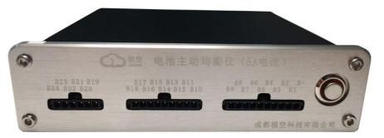

3.4 size

JK-B5A24S size is 138.5mm×134.3mm×32mm

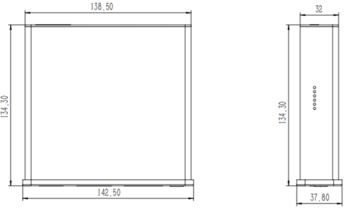

3.5 Weight

Weight about 520g。

3.6 wiring method

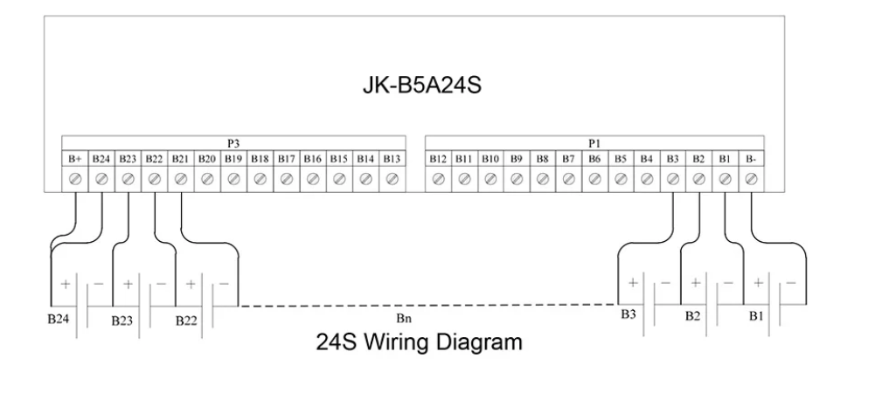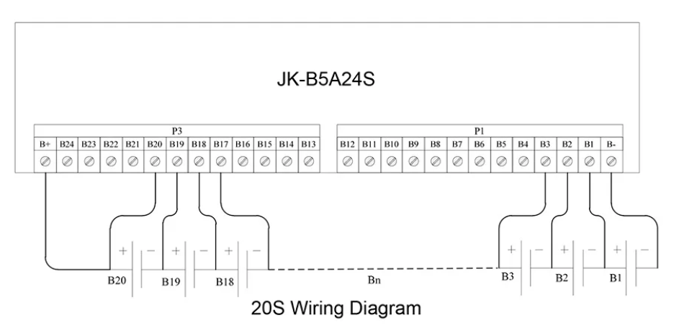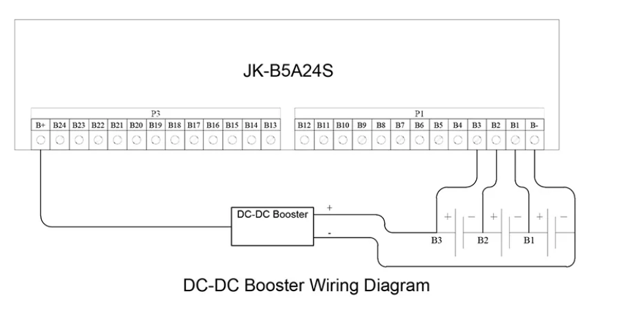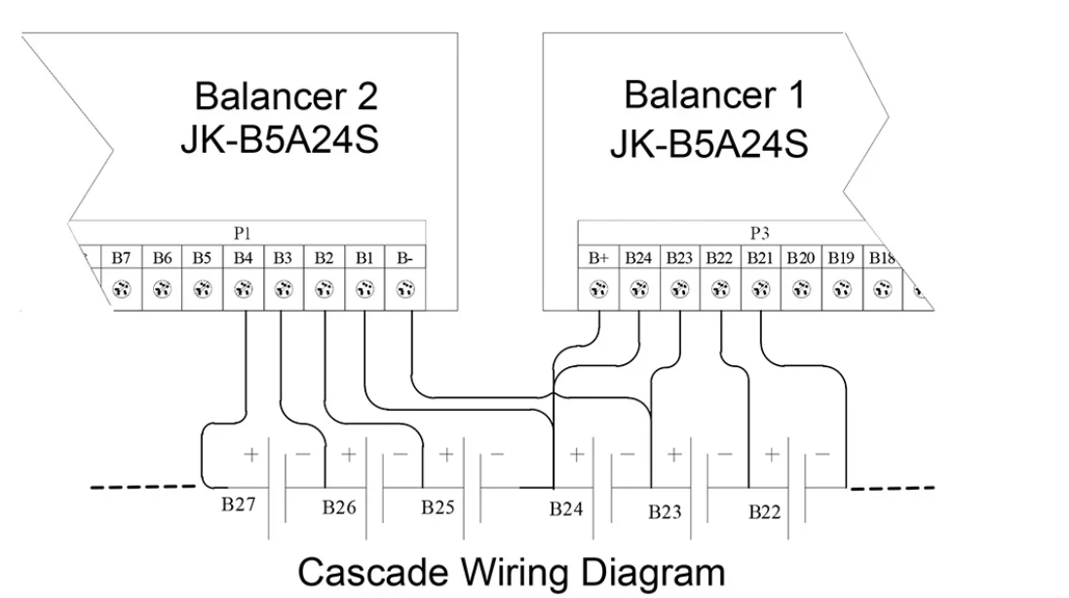

4.3 use the adapter board

The use of adapter boards allows for seamless connection between the sampling cables of the balancer and the battery pack protection board, improving maintenance efficiency, simplifying the maintenance process, and reducing maintenance costs. It is commonly used in battery balancing repair situations.

The interface description of the adapter board is shown in Figure 6, and the usage case of the adapter board is shown in pic below:

2.54mm pins, pins with the same serial number next to the pins represent the same node. When there are multiple plugs in the sampling cable of the protection board, they are alternately inserted on the two rows of pins in order

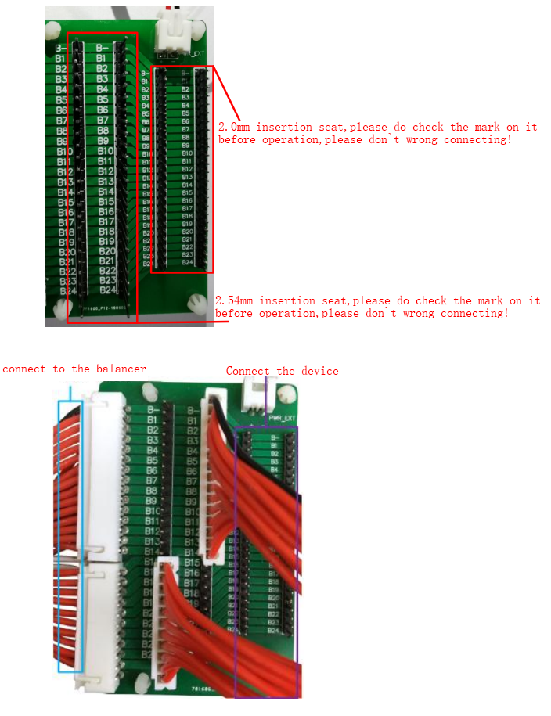

4.4 APP installation

Android phone users can obtain the corresponding mobile app by scanning the QR code shown in Figure 8, while Apple phone users can directly search for "Jikong BMS" in the Apple Store App Store to download and install it.

Figure 8 Mobile APP Connection QR Code

5 Usage and Operation

5.1 Preparation and inspection before use

Before turning on the power and using it, please confirm again whether the balance cable is connected properly and check if the balance meter has been securely placed

Only after confirming that there are no errors can the power supply of the balancer be connected, otherwise it may cause serious consequences such as abnormal operation or even burning.

5.2 Power on operation of the balancer

After confirming the above operation is correct, you can press the balance switch to power on the balance device and let it work.

5.3 APP operation instructions

5.3.1 Equipment operation

a) Device Connection

First, turn on the Bluetooth on your phone, then open the app as shown in Figure 9.

Click on the icon in the upper left corner to scan the device, wait for the scan to complete, and then click on the name of the device that needs to be connected, such as "JK - B5A24S". When connecting for the first time, the APP will prompt for a password. The default password for the device is "1234". After the device is connected, the APP will automatically record the password. There is no need to enter a password for the next connection. After opening the APP, it will automatically connect, and the password input interface will be displayed

As shown in Figure 10.

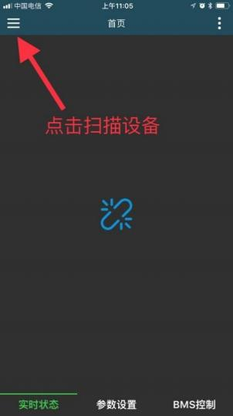

pic 9 device scan

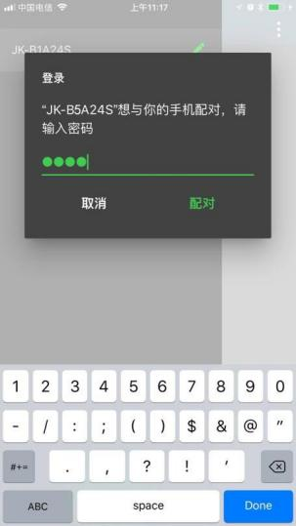

pic 10 input password

b) Change password and name

After connecting the device, click on the pen icon on the right side of the device list to modify the device name and password.

The interface for modifying device names is shown in Figure 11. Please note that device names only support English or numbers and not Chinese

Name and Chinese characters.

The password modification interface is shown in Figure 12. To change the device password, you must first enter the old password of the device. Only when the current password is correct can you enter the option for entering the new password. After entering the new password twice, select confirm to complete

Change the device password.

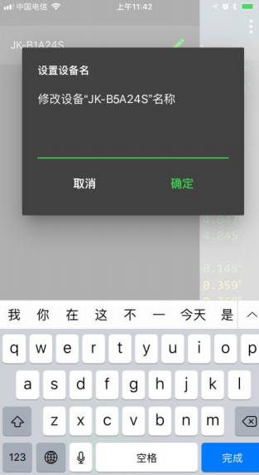

pic 11 name modify

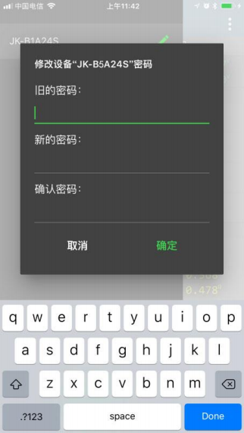

pic 12 password modify

5.3.2 status checking

The real-time status interface is shown in Figure 13

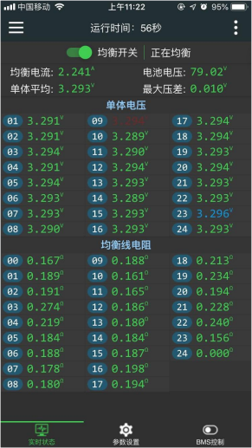

pic 13 real time display

On the real-time status page, you can view individual voltage, battery voltage, maximum voltage difference, individual average, equilibrium status, and average

Balance current, balance line resistance, and other information.

The definitions of each parameter are as follows:

a) Individual voltage

The individual voltage area displays all individual voltages of the current battery, with blue indicating the highest voltage individual and red indicating the lowest voltage individual.

During balancing, the blue battery is discharged to the balancer for temporary storage, and then the balancer charges the stored energy to the red battery. Complete an energy transfer.

b) Balanced current

Real time display of the current balanced current.

When balancing is in progress, blue represents the discharged battery and red represents the charged battery. Negative current indicates that the battery is being discharged

Electricity, blue flashes at this time, positive current indicates that the battery is charging, and red flashes at this time.

The principle of balancing in a balancer is to take electricity from a high voltage battery, store it in the balancer, and then discharge it to a low voltage battery. After the balance is turned off, the balance meter needs to release all the stored electrical energy internally, so there will still be current within one minute after the balance is turned off, which is normal.

c) Battery voltage

The battery voltage represents the total voltage of the current battery and is also the sum of all individual cell voltages.

d) Maximum pressure difference

The maximum voltage difference represents the difference between the highest and lowest cell voltages of the current battery group.

e) Balanced line resistance

The resistance of the balance line represents the resistance of the connection between the balance meter and the battery electrode. This value is only an initial calculation, aimed at preventing incorrect wiring or poor contact. When an alarm appears indicating "excessive resistance in the balanced line," please check the wiring.

5.3.3 Parameter settings

The parameter settings page is shown in Figure 14.

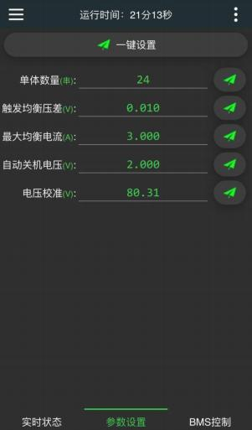

pic 14 parameters settings

On the parameter settings page, you can set the number of units, trigger balanced voltage difference, maximum balanced current, automatic shutdown voltage, and electricity

Pressure calibration and other parameters.

The definitions of each parameter are as follows

a) Number of monomers

The number of individual cells represents the current number of battery cells. Before use, please accurately set this value, otherwise the balancer will not work properly.

b) Trigger balanced pressure difference

Triggering equilibrium pressure difference is the only parameter that controls equilibrium. When the equilibrium switch is turned on, equilibrium begins when the maximum pressure difference of the battery pack exceeds this value, and ends when the pressure difference is below this value. For example, setting the triggering voltage difference for equalization to 0.01V, equalization starts when the voltage difference of the battery pack is greater than 0.01V, and ends when it is lower than 0.01V. (It is recommended to set the balanced triggering voltage difference to 0.005V for batteries with a capacity of 50AH or above, and 0.01V for batteries with a capacity of less than 50AH.).

c) Maximum equilibrium current

Balanced current represents the continuous current during energy transfer between the discharge of high-voltage batteries and the charging of low-voltage batteries. The maximum equilibrium current represents the maximum current during the energy transfer process, and the maximum equilibrium current should not exceed 0.1C. For example, a 20AH battery should not exceed 20 * 0.1=2A.

The maximum balancing current that can be set for the JK-B5A24S balancer is 5A.

d) Automatic shutdown voltage

The automatic shutdown voltage represents the minimum voltage at which the balancer operates. When the voltage of the highest cell in the battery pack is lower than this value, the balancer will shut down (this value is not commonly used, it is recommended to keep the default voltage of 2.8V).

e) Voltage calibration

The voltage calibration function can be used to calibrate the accuracy of the voltage acquisition of the balancer.

When there is an error between the total voltage collected by the balancer and the total voltage of the battery, the voltage calibration function can be used to calibrate the balancer. The calibration method is to fill in the current measured total voltage of the battery, and then click on the small button after voltage calibration

Aircraft, complete calibration.

Note: After modifying any parameter, you need to click on the "Small Aircraft" after the parameter to complete the parameter distribution

After successfully receiving the parameters, the weighing instrument will emit a beeping sound.

6 General fault analysis and troubleshooting

The cause and handling of the malfunction are shown in Table.

Fault Causes and Handling

|  |  |  |  |  |
| --- | --- | --- | --- | --- |
| ITEM | Fault phenomenon | cause analysis | Troubleshooting | remark |
| 1 | The power indicator light is not on | The power supply to the balancer is abnormal | Check if the power pin on the connector is connected to the power source. |  |
| 2 | APP cannot search for devices | The APP is far from the device | It is advisable to maintain a distance range of about 2-3 meters |  |
| 3 | The APP prompts that the number of individual settings does not match the set value | Incorrect number of individual settings or abnormal connection of balance lines | Check if the number of individual settings is the same as the number of connected batteries. |  |
| 4 | APP prompts that the resistance of the balancing line is too high | The line resistance from the battery to the connector is too high | Check for poor contact between the battery cell and the connector, otherwise replace the wire. |  |